I’ve coded the following three CPU Scheduling methods: First Come First Serve (FCFS), Shortest Job Remaining (SJF), and Round Robin (RR). In an effort to determine which of the following scheduling processes were the most effective. In order to do this, I need to have similar numbers for each of the scheduling processes, in order to accurately measure and compare. I will be using ten numbers at random from 1-10, results shown as:

Processes: {1, 2, 3, 4, 5, 6, 7, 8, 9, 10}

Burst Time: {2, 7, 5, 8, 9, 1, 3, 4, 10, 6}

Arrival Time: {0, 3, 7, 1, 2, 10, 5, 3, 8, 9}

**Output for FCFS:**

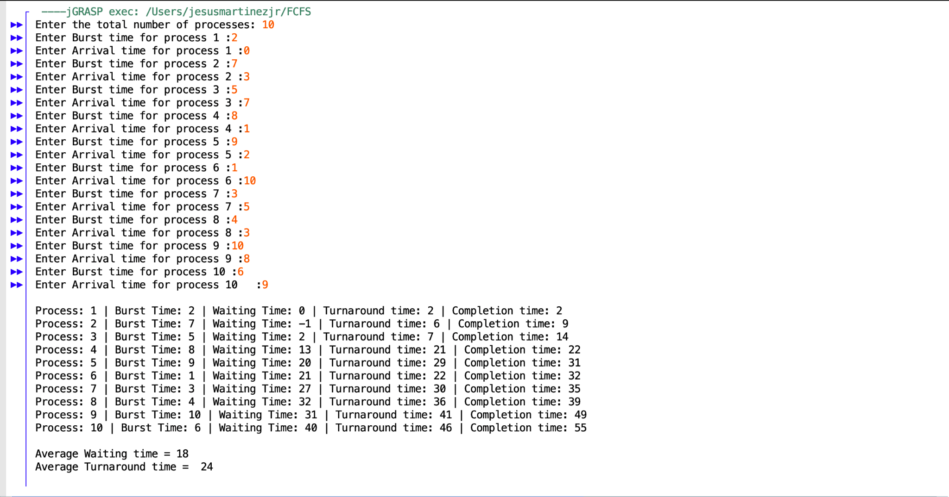

**Output for SJF:**

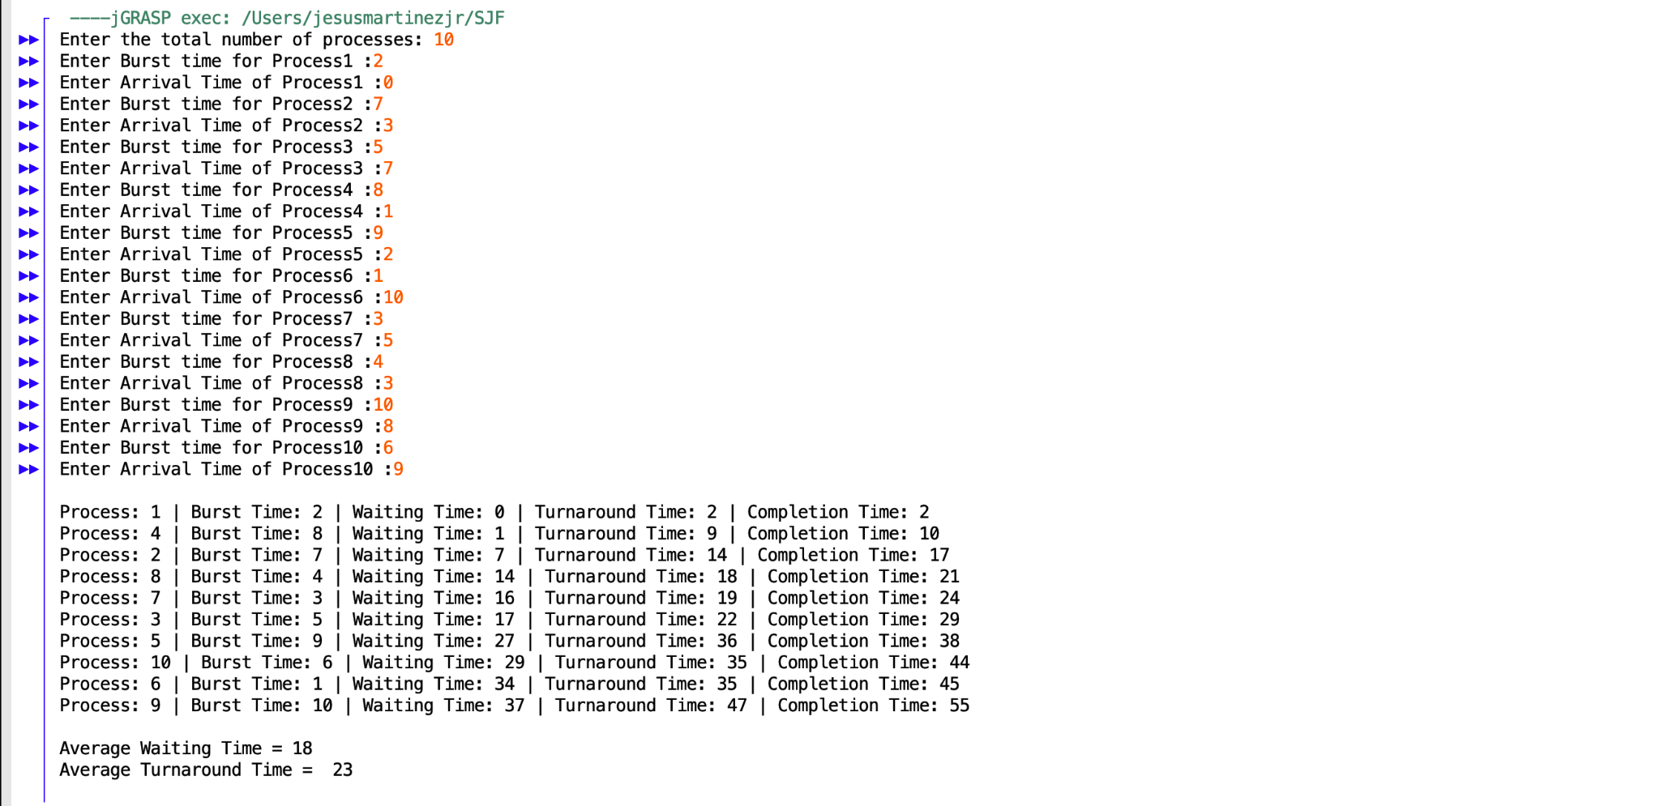

**Output for RR:**



Based on the outputs, we can conclude that Round Robin would be the least effective given that it has the longest waiting time, and the longest turnaround time. The most efficient would be SJF, given that while it does have the same Wait Time as FCFS, it has a quicker turnaround time. Since it’s quicker and more efficient, this is the best scheduling algorithm to use.